# **Koushik Sekar**

# **CIDR-Classless Inter-Domain Routing**

**Classless Inter-Domain Routing (CIDR) is an IP address allocation method :**

* **Every computer, server, and end-user device that uses the internet is assigned a special number called an IP address.**
* **These IP addresses are used by devices to locate and communicate with one another. Companies use CIDR to efficiently and flexibly distribute IP addresses throughout their networks.**
* **Creating IP continuous manner to avoid the wastage of Internet protocol.**

### **Different IP address formats:**

**There are two different addresses in IP called Network address & Host address**

**Network address:**

**The network address is a string of digits that points to the network's unique identifier.**

**Host address :**

**The host address is a string of numbers that represents the network's host or individual device identifier.**

**Ip classful IPV4 addresses :**

**Class A :**

* **It has has 8 network prefix bits**
* **In the Image it Class A contains the private IP 10.0.0.0 > where 10. Referred as network address & last digit 0.0.0 is Host address we can modify the range up to 255.255.255**
* **This class supports 1,67,77,214 hosts.**

**Class B :**

* **It has has 16 network prefix bits**
* **In the Image it Class B contains the private IP 172.16.0.0 > where 172.16 Referred as network address & last digit .0.0 is Host address we can modify the range up to 31.255.**
* **This class supports 65,534 hosts.**

**Class C :**

* **It has has 24 network prefix bits**
* **In the Image it Class B contains the private IP 192.168.0.0 > where 192.168.0 Referred as network address & last digit .0 is Host address we can modify the range up to .255**
* **This class supports 254 hosts.**
* **Ref Img:**

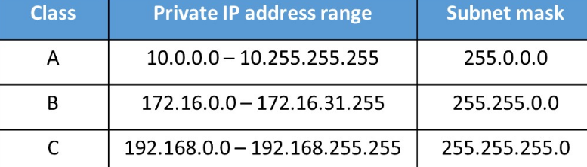

# **AWS regions vs AWS availability zones list**

## **AWS regions:**

**There are total 31 regions in operation around the globe as of now. Each regions has its own significant code . Every regions has lot of data service centre's.**

**AWS availability zones:**

**There are total 99 zones across 31 regions in the globe as of now. Each availability zone has a code that is derived from the AWS region code that corresponds to it, followed by a letter in sequential order.**

**India AWS regions vs Availability zones:**

**There are total 2 regions in India with 6 availability zones.**

**Availability Zones:**

* **Mumbai with 3 availability zones**
* **North Virginia is with 6 availability zones**
* **Sydney is with 6 availability zones**

**IPv4 vs IPV6:**

**Ipv4 uses 32-bit.**

**Ipv4 capable enough manage 4.3 billion hosts. ping IP:address. It supports VLSM.**

**IPv6 uses 128-bit it can manage infinite number of hosts. ping 6.It will not supports VLSM.**

# **Server :**

**A server is a computer program or device that provides a service to another computer program and its user, also known as the client.**

# **TCP & UDP:**

## **TCP:**

**There are 65,535 Open ports available for communication between devices.**

**Transmission Control Protocol (TCP) is a standard that defines how to establish and maintain a network conversation by which applications can exchange data.**

**TCP works with the Internet Protocol (IP), which defines how computers send packets of data to each other.**

## **UDP:**

**In computer networking, the User Datagram Protocol is one of the core communication protocols of the Internet protocol suite used to send messages to other hosts on an Internet Protocol network. Within an IP network, UDP does not require prior communication to set up communication channels or data paths.**

## **TCP & UDP ports:**

**These ports are assigned to specific server service by the Internet Assigned Numbers Authority (IANA). For example, port 80 is used by web servers.**

**Port 0 to 1023: These TCP/UDP port numbers are considered as well-known ports.**

**Port 1024 to 49151: These are ports that an organization, such as application developers, can register with IAMA to be used for a particular service. These should be treated as semi-reserved.**

**Port 49152 to 65535: These are port numbers used by client programs, such as a web browser. When you visit a web site, your web browser will assign that session a port number from within this range. As an application developer, you are free to use any of these ports.**

## **CIDR - Calculation:**

**IP : 10.0.0.0/16:-**

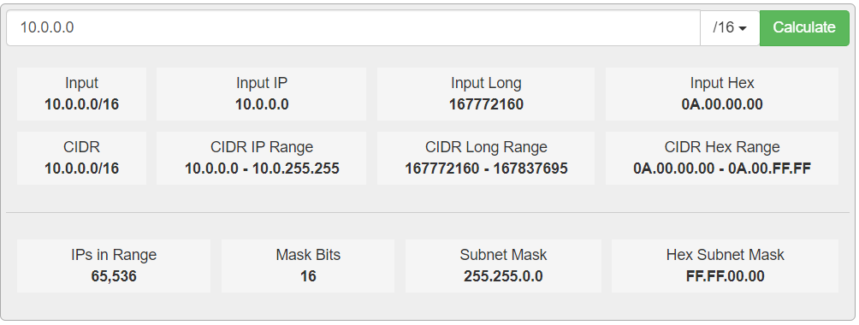

**IP : 10.0.0.0/24:-**

# 